Pricing & AvailabilityAPP-Using MAF

Functional Specifications & Design Document

Document Control Information

Document Information

|  |  |
| --- | --- |
| Document Identification |  |
| Document Name | **Pricing & Availability App_Functional Specification and Design Document** |
| Document Author | Saurabh Gulati/Samikhya Joshi |
| Document Version | 0.1 |
| Document Status | Draft |
| Date Released |  |

Document Edit History

| Version | Date | Additions/Modifications | Prepared/Revised by |
| --- | --- | --- | --- |
| DRAFT | 05-Jun-2015 | Initial Version | Saurabh Gulati/Samikhya Joshi |
|  |  |  |  |
|  |  |  |  |
|  |  |  |  |

Document Review/Approval History

| Name | Organization/Title | Comments |
| --- | --- | --- |
|  |  |  |
|  |  |  |
|  |  |  |
|  |  |  |
|  |  |  |

Distribution of Final Document

The following people are designated recipients of the final version of this document:

| Name | Organization/Title |
| --- | --- |
|  |  |
|  |  |
|  |  |
|  |  |

Table of Contents

1 Applications Overview 4

1.1 Objective 4

1.2 Business Needs 4

1.3 Major Features 4

1.4 Modules Involved 4

1.5 Systems Involved 4

1.6 Assumptions 4

1.7 Dependencies and Prerequisites 5

1.8 Related Documents 5

1.9 Nomenclature 5

2 Functional Approach / Process Description 6

2.1 Navigation Flow Diagram 6

2.2 Flow description 6

3 Application and Tool Setup Requirements 8

4 Detailed Functional Specifications 9

4.1 Layout Specifications 9

4.1.1.1 Form Layout 9

4.1.1.2 Login screen: 9

4.1.1.3 Dashboard screen: 10

4.1.1.4 Springboard 10

4.1.1.5 Pricing and Availability Screen: 11

4.1.1.6 My Cart screen 11

4.1.1.7 My Orders screen 12

4.2 Business Rules 13

4.3 Test Scenarios 13

5 Other Requirements 14

5.1 Volume and Performance Requirements 14

5.2 Initiation, Frequency, and Scheduling Requirements 14

5.3 Security and Controls Requirements 14

6 Exception and Error Handling 15

6.1 Log Output 15

6.2 Restart Procedures 15

7 Open/Closed Issues 16

7.1 Open Issues 16

7.2 Closed Issues 16

8 Appendix – Misc. Attachments 17

# Applications Overview

## Objective

This document forms a basis for the detailed functional design for Pricing and Availability application. It captures all business requirements and business rules required for the technical design approach. It will also portray the high level logical process flow diagram where required for this requirement. This document is intended to provide the developer with necessary information to implement effective and accurate design and build of the mobile application.

## Business Needs

This app is intended mainly to provide all the necessary infrastructure to any client organization to access the product pricing and availability information using any of the standard android or iOS mobile device.

## Major Features

The following major features are expected from this app

* Role based product pricing view
* Display the discounts associated to the product
* Apply manual discounts
* Display the latest available date and availability for a product
* View all orders created by the sales person/customer service representative
* Add selected items to the order

## Modules Involved

The following modules are involved in the working of this personalisation

* Oracle Order Management
* Oracle Advanced Pricing

## Systems Involved

* Oracle EBS
* Oracle Weblogic Server.

## Assumptions

1. Mobile device connectivity must be present for all features and capabilities to function properly
2. The user interface will be device agnostic.
3. The application user interface should fit all mobile device screens (iPhone, iPad, etc.) and should adapt based on portrait vs. landscape orientation. Screens will be optimized for Phone size screens. Future enhancements to the design of the mobile app will incorporate design of screens optimized for tablet sized screens.
4. The mobile application would leverage standard Oracle functionality and nomenclature
5. Language used in the prompts is the language used by the current language pack of the mobile operating system.
6. Items must have an active status and must be ATP enabled to derive the correct availability information. Items would not appear in the Availability screen if the items are not ATP enabled.
7. Sourcing rules would be defined for the item to derive correct availability information.
8. Only automatic discounts will be applied on the item and would be available for viewing to the respective stakeholders. Manual discounts would not be available for application to the salesperson or customer service staff.
9. Pricing and availability search functionality would only be available for ATO, PTO and standard items. Kits and models would not be available for price and availability check functionality.
10. The platform-specific build tools should be available from the specified platform SDK.
11. All users must be created as a User in Oracle EBS. Internal users would be identified if the Person field is populated for the user. If the Customer field is populated for the User, user profile would be identified as External user.

## Dependencies and Prerequisites

1. Oracle EBS instance R12.1.1.3 should be available for OAF side development.
2. Oracle weblogic server 11g.

## Related Documents

The following documents are related to this document

|  |  |  |
| --- | --- | --- |
| Document Name | Revision | Document Description |
|  |  |  |

## Nomenclature

| Acronym | Meaning | Description |
| --- | --- | --- |
| ADF | Application Development Framework | Oracle ADF is an end-to-end Java EE framework that simplifies application development by providing out-of-the-box infrastructure services and a visual and declarative development experience. |
| SOA | Service oriented Architecture | A service-oriented architecture (SOA) is the underlying structure supporting communications between services. SOA defines how two computing entities, such as programs, interact in such a way as to enable one entity to perform a unit of work on behalf of another entity. |
| OAF | Oracle Application framework | Oracle Application Framework (OA Framework or OAF) is a proprietary framework developed by Oracle Corporation for application development within the Oracle E-Business Suite (EBS). The framework is also available to customers for personalization’s, customizations and custom-application development. |
| ATP | Available To Promise |  |

# Functional Approach / Process Description

## Navigation Flow Diagram



## Flow description

1. User switches on the mobile device and opens the Pricing APP with one of the following profiles :
   1. Internal - Business User, Sales person and Customer Service Staff
   2. External - Customer
2. Dashboard will be displayed to the respective user
3. If User clicks on Springboard icon, different navigation options becomes available to user

* Pricing and availability Dashboard
* My Orders Screen
* Settings screen
* About APP screen
* Sign Out

1. The Pricing and availability dashboard will be displayed by default
2. Pricing and availability dashboard would have 2 tabular columns available : New Search and Search History
3. New Search screen would have the following fields available in case of an Internal user :
   1. Item Number(Mandatory)
   2. Item Description (Defaulted based on Item Number)
   3. Customer Number
   4. Quantity(Defaulted to 1)
   5. Request Date(Defaulted to System Date)
4. New Search screen would only display the Item Number field in case of an external user.
5. User enters the required information and selects the search button to navigate to the Pricing and Availability screen
6. Pricing and Availability screen would be divided into 2 tabs : Pricing tab and Availability tab
7. Pricing tab would display the following information for both internal and external users based on search parameters :
   1. List Price of the Item
   2. Selling Price
   3. Discount Amount and percentage(only automatic discounts would be displayed)
   4. Discount Description(only automatic discounts would be displayed)
8. Internal User can add the selected item to the cart using Add to Cart button
9. Manual discounts can be applied using the Apply Coupon button only for the internal users
10. Availability tab displays the Item availability information such as Warehouse, On Hand Quantity and Earliest Available Date to the internal users. Available date is visible to the external users as well.
11. My Cart screen would display all items with their description that have been added to the cart. Internal users can add quantity or delete items from the cart.
12. Internal users click on create order on the My Carts screen to create orders for the selected items. Once the Create order button is selected, users are prompted to enter the Bill to Account Number, Ship to Account Number and the order type information before the order can be created and order number is confirmed.
13. Internal user enters the Account Number and order type information in the popup window, and clicks create order. If the order is created successfully order number is displayed to the users.
14. Internal users can click on the springboard icon to select the my orders screen. My orders screen displays the order number, order status information for all orders created by the sales person.
15. Internal and external users would be identified on the basis of the User screen in Oracle EBS. External users would have the Customer field populated against the User.

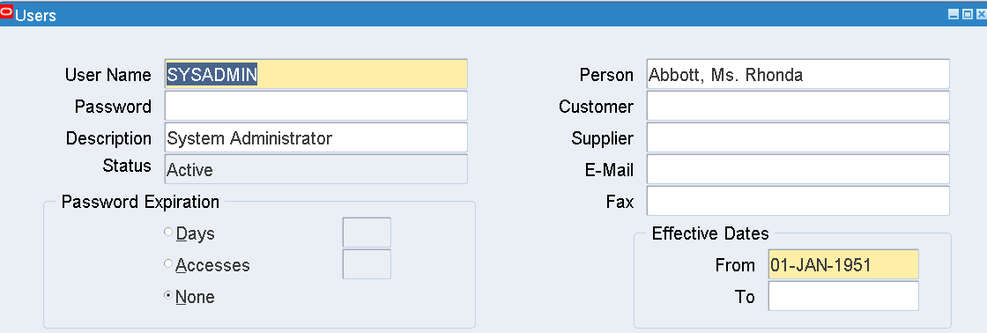

# Application and Tool Setup Requirements

# Detailed Functional Specifications

## Layout Specifications

#### Form Layout

Layout of the My Pricing is given in the diagram below. The below diagrams will be same both for mobile side and application side design.

#### Login screen:

Below is the indicative snapshot of Login screen where user would be prompt to enter customer id and password for logging into this application.

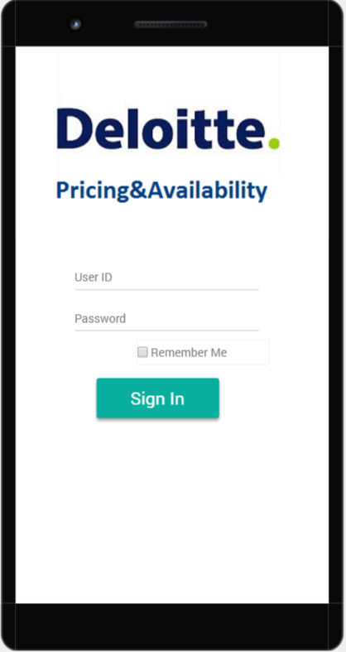

#### Dashboard screen:

Dashboard screen of the app would show the New Search tab as well as the search history tab.

By clicking on **New Search tab**, user can enter one of the following information to search for pricing and availability information

* Item Number(Mandatory)
* Item Description (Defaulted based on Item Number)
* Customer Number
* Quantity(Defaulted to 1)
* Request Date(Defaulted to System Date)
* Price List

External users can search the item without the customer number field. Search Pricing and Availability button would be displayed below these field. Item number field would be an LOV field. Whenever the users enter partial Item number text all items corresponding to the partial search would be available in the LOV. Upon selection of the item in the LOV Item Description field would be auto populated on the search screen.

Item Description and Price List would default on the search screen whenever the Item Number is chosen from the LOV. Rules related to defaulting of the 2 fields have been described in Business Rules section 4.2 BR-01 and BR-05.

By clicking on **Search History** tab, user can see last 10 searches of items based on the settings in the setting screen (refer to section 4.1.1.4).

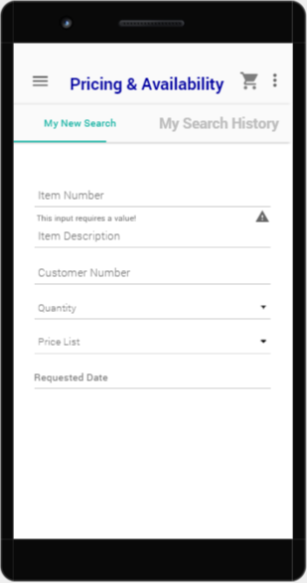

Corresponding Search Screen in EBS: 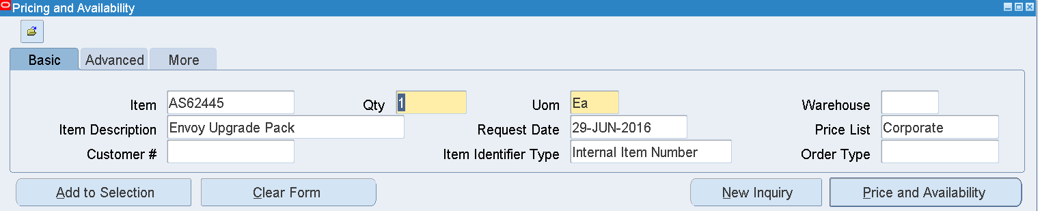

Above is the indicative snapshot of Dashboard screen.

Search history screen would contains below details:

- Item Number: Item number would be displayed.

- Item Description: It represents the description corresponding top the selected item.

- Request Date: The date when the product is required

- Customer Number – The Account number for which the pricing and availability needs to be verified.

- Quantity – Item Quantity for which the price and availability needs to be verified

- Price List

Note: A custom table would be required to store the search history (last 10 searches) done by each user. The search history would then be displayed on the dashboard as a tab.

#### Springboard

On Clicking the Springboard, the below screen will be displayed.

<<insert screenshot>>

This screen provides the below functionality:

- To navigate to the ‘Pricing&Availability Dashboard’ screen which will display Item Pricing and availability search capability as well as search history.

-To navigate to the ‘My Carts’ screen which will display

- To navigate to the ‘My Orders’ screen which will display all orders created by the internal users along with the status details of these orders.

- To navigate to the ‘About’ screen for application details

- To navigate to the ‘My Notifications’ screen for the alert details on the items

- To navigate to the ‘Sign Out’ screen to sign out from the application

- To navigate to the ‘Settings’ screen to change and access settings (refer to below screenshot)

**<<insert screenshot>>**

#### Pricing and Availability Screen:

Pricing and availability screen would consist of the following 2 tabs:

* Pricing Information
* Item Information

Under the Pricing information tab the following information can be viewed:

1. Item List Price
2. Item Selling Price
3. Currency
4. Discount Amount and percentage(only automatic discounts would be displayed)
5. Discount Description(only automatic discounts would be displayed)
6. Discount End Date

Under the Availability information tab the following information can be viewed:

1. Availability (for that default organization) – This corresponds to Available to Reserve field in Oracle EBS
2. Earliest Available Date (Only for the internal users)
3. Warehouse from which the item would be available(only visible to the internal users)
4. Item UOM
5. ATP enabled

Below the Pricing tab Add to Cart button would be available to add the item to the cart.

If the items are successfully added to the cart a success message must be shown to the users. Incase the user presses an item to be added to cart and if it’s already present in the cart an error message would be displayed to the user.

Corresponding Pricing screen in EBS:



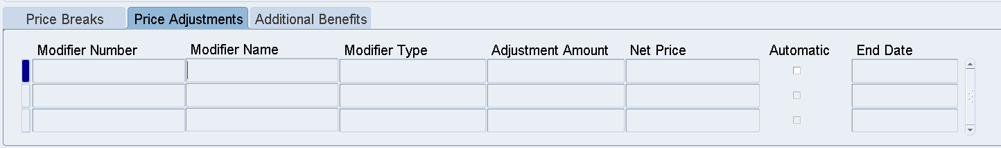

Corresponding Availability screen in EBS:

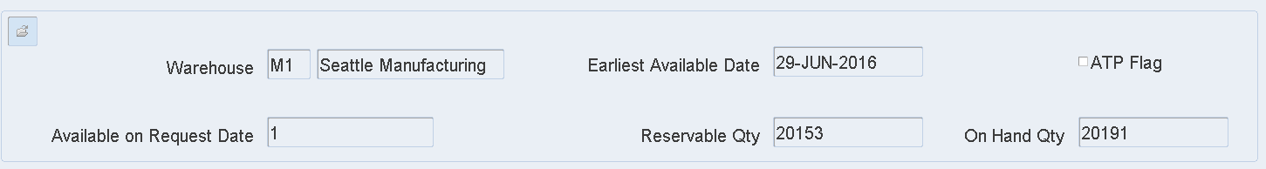

<<insert screenshot>>

**Sourcing details for the pricing and availability information**

The pricing information would be derived by using the pricing request API QP_PREQ_PUB.PRICE_REQUEST with item and price list as parameters to be passed. Refer to the document ID (412545.1) to get the queries corresponding to the pricing attributes call from pricing and availability form.

#### My Cart screen

The cart details can be viewed by accessing the Springboard as shown in section 4.1.4.

My Cart hyperlink will also be available on every screen at the upper right corner. The hyperlink will be displayed as an image. Sample image is shown below:



The Cart symbol will point to the same screen as ‘My Carts’ link in the springboard.

Cart screen would be visible only to the internal users. Cart Screen would display the following details

* 1. Item Name – All items that were added to the cart from the Pricing and availability screen
  2. Item Description – Description corresponding to these items
  3. Quantity – Quantity of the item selected in the Pricing and availability screen. This should be displayed along with + - buttons which would allow users to add or reduce the quantity
  4. Delete Button - Delete Item button below each individual item and would allow users to select and remove the items from the cart
  5. Total Amount – This field would display the total sum for all items multiplied by quantities present in the cart.
  6. Coupon Text Field – This free text field would be available below items listing. Internal users can enter the coupon number which should correspond to a modifier number. There would be no validations on the free text field.
  7. Apply Coupon Button- This would allow internal users to apply manual discounts against the total cart amount. This would be available below items listing and to the right side of the coupon text field. Coupon name entered must be matched to a manual discount modifier number to be applied to the cart amount upon clicking the apply button. Incase the Coupon text is blank an error message must be shown to the users.
  8. Create Orders Button – Upon pressing of Create Orders button a pop up message would be generated on the screen. Internal users would be prompted to enter the following required fields for the order to be created – Ship To Account Number, Bill To Account Number and Order Type. Order Type would be a list of values field and would display all order types for the default organization. Upon selection of the 3 fields a confirm button would be displayed on the pop up window. Once the user selects the required fields and presses the confirm button, Process Order API would be called to create the order in entered status. If successful order number would be displayed to the users on the cart pop up screen. All item selections from the cart would be deleted once the order number is generated and displayed on the users screen.

The above mentioned fields have been displayed in the application snapshot below:

<<insert screenshot>>

#### My Orders screen

My Orders screen can be viewed by accessing the Springboard as shown in section 4.1.4. This would be a view only feature available to internal users only. This screen would display No Records found in case the user has not been selected as the Sales person on any of the orders.

My order screen would display the following fields:

1. Order Number – All orders created by the user would be displayed
2. Order Date : Date of Order Creation
3. Order Amount – The total order amount for the orders created by the Sales person.
4. Order Status – This would display the current order flow status code for the orders created by the internal user(sales person)

#### My Notifications Screen

#### My notifications screen would display all notifications raised for the salesperson. Notifications would be created every time there is an update to the Order header status for all orders having that particular sales person. Order header status can have the following values: Entered, Booked, Cancelled and Closed.

## Business Rules

The following business rules are to be actioned every time a line is added to or changed on a time sheet:

**BR01 – Item Description should be auto selected upon selection of Item in the dashboard screen.**

Item Number is a mandatory List of Values field. Whenever user enters partial text Item Numbers with the text would appear in the LOV. Once the user selects the Item Number from the LOV, corresponding Item Description field would be auto populated in the New Search screen.

**BR02 – Only ATP enabled Active items will be displayed on the Availability Screen.**

If the internal users search an ATP disabled item only the Pricing details will be populated for the item in the Pricing and availability screen. If the Availability tab is selected by the user a message must be displayed to the user that item is not ATP enabled.

**BR03 – Only Standard Items, ATO and PTO will only be considered for Pricing and availability search functionality**

Pricing and availability search would only be applicable for Standard Items,PTO’s and ATO items. This application would not support Models Kits and Configuration items. Incase any of these item types are selected in the search, a message must be shown to the users “Invalid item type selected”.

**BR04 – Alert to be sent if the User order status is updated**

Alert should be sent to the internal users whenever the status of the orders created by that particular user is updated. Alerts would be available on the springboard.

**BR05 – Default price list would be used to determine the price of an item**

Default price list stored in a custom lookup would be used to determine Item prices. Incase the item is not present in the default price list an error message would be displayed to the user. This would also ensure avoiding of conflicts in case an item is defined in multiple price lists. Upon selection of the Item in the new search screen default price list should be defaulted in the Price List LOV. If the item does not exist in default price list then the price list should be displayed in alphabetical order with the first price list being displayed in the Price List LOV.

**BR06 – Coupon Number must be verified against the EBS ‘Coupon’ value set**

Coupon entered by the internal user would be validated against an existing modifier for the discount to be applied while creating the order in My Cart Screen.

There are 2 actions expected when an internal user presses the Coupon apply button on the My Cart Screen:

1. The coupon number would be verified against a Coupon Value set which would store all coupons that are expected to be applied against the order. If the coupon number matches the value set line Total order amount displayed on the screen must be reduced by the percentage amount displayed in the corresponding description of the value set. This reduced amount must be displayed under the total amount along with the discount percentage.
2. Once the internal user presses Create Order button if the coupon is populated the Pricing Context must be populated on the EBS order while creating the order in EBS via Process Order API before calling the pricing engine. Pricing Context value at the line level should be ‘Coupon’. The Pricing Context DFF value would be populated with the Coupon number entered by the internal user.

A Pricing Context Attribute – ‘Coupon’ would be created in EBS. Attribute would be associated with the value set – ‘Valid Coupons’. This value set would store all valid values of coupons available. The ‘Coupon’ attribute would then be linked to Order fulfilment process. A new Pricing formula – ‘Coupon Pricing’ would be created. The formula would list down the factors on which the coupon % would be determined based on the value stored on the value set. E.g. Pricing Formula factor List would apply an adjustment of .1 in case COUPON10 is selected. Similarly an adjustment .2 would be applied to the list price if the value COUPON20 is chosen by the user.

Coupon Pricing formula would then be associated with a modifier. Modifier – Coupon C1 would be an automatically applied modifier. At the line level of the modifier the Pricing formula would be associated and the modifier would be applied as an Amount Modifier to the list price.

Hence whenever a user applies a coupon and presses the create order button the coupon would be verified against the value set in the pricing formula to determine the adjustment amount. The modifier amount would then be applied against the order line if the Order Header Source is populated as Molbile.

**BR07 – Item Availability and pricing details would be displayed for the corresponding organization**

Users can select the country from the springboard My Settings section. Any Pricing and availability search done for items would be applicable for the operating unit corresponding to the country settings. ATP API call would be made to determine the item availability for the default organization. Similarly Pricing request API to determine pricing details of the item would be done for the operating unit corresponding to the country selected.

## Test Scenarios

|  |  |  |
| --- | --- | --- |
| No. | Test Case | Expected Outcome |
| 1 |  |  |
| 2 |  |  |
| 3 |  |  |
| 4 |  |  |
| 5 |  |  |

# Other Requirements

## Volume and Performance Requirements

<Specify the volume and performance requirements here.>

## Initiation, Frequency, and Scheduling Requirements

<Specify the initiation, frequency, and scheduling requirements here.>

## Security and Controls Requirements

<Specify the security and control requirements here.>

# Exception and Error Handling

|  |  |  |  |
| --- | --- | --- | --- |
| S. No. | Error / Warning / Information | Description | Handling Process |
|  |  |  |  |
|  |  |  |  |
|  |  |  |  |
|  |  |  |  |
|  |  |  |  |
|  |  |  |  |

## Log Output

<Layout the log output requirements for the extensions>

## Restart Procedures

Restart procedures for <Component Name> concurrent program are as follows:

Bullet1

Bullet2

Bullet3

# Open/Closed Issues

<List open and closed issues specific to this object. Broader or escalated issues should be logged in the project Issues Log.>

## Open Issues

< Define any open issues >

|  |  |  |  |
| --- | --- | --- | --- |
| No | Desc | Responsibility | Target Date |
|  |  |  |  |
|  |  |  |  |
|  |  |  |  |

## Closed Issues

< Define any closed issues >

|  |  |  |  |
| --- | --- | --- | --- |
| No | Desc | Resolution | Impact Date |
|  |  |  |  |
|  |  |  |  |
|  |  |  |  |

# Appendix – Misc. Attachments

<Any misc. attachments>

About Deloitte

Deloitte provides audit, tax, consulting, and financial advisory services to public and private clients spanning multiple industries. With a globally connected network of member firms in 140 countries, Deloitte brings world-class capabilities and deep local expertise to help clients succeed wherever they operate. Deloitte's 165,000 professionals are committed to becoming the standard of excellence.

Deloitte's professionals are unified by a collaborative culture that fosters integrity, outstanding value to markets and clients, commitment to each other, and strength from cultural diversity. They enjoy an environment of continuous learning, challenging experiences, and enriching career opportunities. Deloitte's professionals are dedicated to strengthening corporate responsibility, building public trust, and making a positive impact in their communities.

Deloitte refers to one or more of Deloitte Touche Tohmatsu, a Swiss Verein, and its network of member firms, each of which is a legally separate and independent entity. Please see www.deloitte.com/about for a detailed description of the legal structure of Deloitte Touche Tohmatsu and its member firms. Please see <http://www.deloitte.com/us/about> for a detailed description of the legal structure of Deloitte LLP and its subsidiaries.

Internal Usage Statement

This publication is for internal distribution and use only among personnel of Deloitte Touche Tohmatsu, its member firms, and its and their affiliates. Deloitte Touche Tohmatsu, its member firms, and its and their affiliates shall not be responsible for any loss whatsoever sustained by any person who relies on this publication.

Copyright © 2012 Deloitte Development LLC. All rights reserved.

Member of Deloitte Touche Tohmatsu